BST Remove
Answers

- Is this a binary search tree? Y/N How do you know?
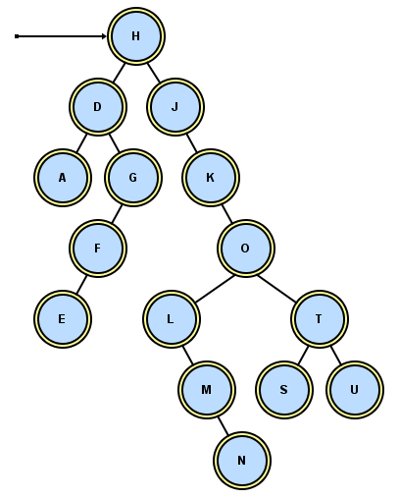
At each node, the smaller are to the left, the larger are to the right

- When you remove a node, you have to preserve the BST order. Suppose you remove O. What letter(s) should go in its place? N or S
How do you find that letter?
N is the largest value in the left subtree. We will do that.
(S is the smallest in the right subtree.)
Then set M's right to null.

- Suppose you remove G. What letter(s) should go in its place?_F_
How do you find that letter?
D's right points to F. G’s parent points to G’s child.

- Suppose you remove D. What letter(s) should go in its place?A or E
How do you find that letter?
We will take the greatest in the left subtree. A is a leaf. A replaces D, and the first A’s parent points to null.

- Suppose you remove K. What letter(s) should go in its place?_O_
How do you find that letter?
J has one child! J’s right points to O, i.e., K’s parent points to K’s child.

- Suppose you remove U. What should go in its place?_null
How do you find that letter?
Set T's right to null, i.e. set U’s parent’s right to null.

- Suppose you remove S. What should go in its place?_null
How do you find that letter?
Set T's left to null, i.e., S’s parent's left is set to null.

- Suppose you remove the root, H. What should go in its place?_G or J. Largest in the left subtree.
Is deleting the root a special case or not? Sometimes!

- What case(s) have we missed? remove the root N when N has only one child.
remove the root N when N is also a leaf. (i.e., the tree has one node.)

- Describe and organize all the different cases:

Algorithm for Removing a Node from a BST
Answers

Most people keep track of two pointers, a parent and a current.
Find the node to remove, updating parent and current as you go. Then identify which case:
(1) If the node is a leaf, just set its parent pointer to null.
(2) If the node has just one child (left or right), point the parent to current's child (in case the root is also a leaf and we need to remove it just set root to null).
(3) If the node has two children, find the node containing the largest item in the node's left subtree and replace (use setValue) the node's object with the largest item. Identify the parent of the largest item. Set the parent’s pointer either to null or to the removed node’s left child.
Return the root.

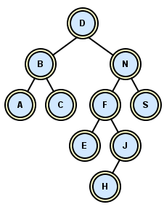

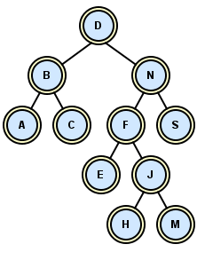
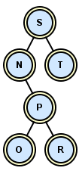
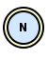
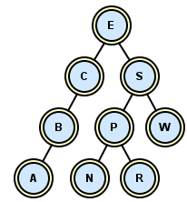
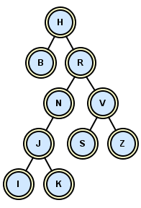
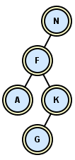
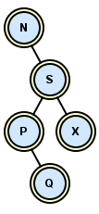
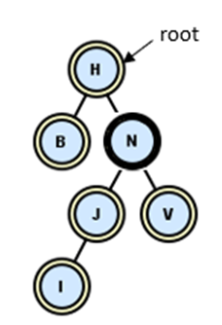
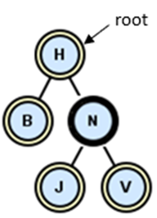
Let's try it out. For each N in each tree, remove the N and re-draw the pointers:
Case 1b)
Case 2a)
Case 2d)
Case 1a)
Case 3c)
root
root
root
root
root
root
Case 2c)
root
Case 3a)
Case 3b)
Case 2b)
NULL
M
NULL
NULL
J
J
NULL
Case 3d)
J
For each N in each BST, remove it properly.
root
G
M
NULL

Let’s try it again:
Case 1 a: if target is a leaf (but not the root). . .
b: if the target is a leaf and a root…
Case 2 a: if target has one child to right . . .
b: if target has one child to left . . .
c & d: if target has one child and is the root…
Case 3: target has two children, even if the target is the root.
a: if the maximum of the left subtree is a leaf…
b,c,d: if the maximum of the left subtree is not a leaf…

CHALLENGE: do it recursively! The basic idea: if this node contains the element to be removed, find the value that will replace it, setValue to that value, then use a recursive call to remove the new value from the appropriate subtree. (For example, in case 3a, we would set the N node to M, then remove M from the subtree starting with F.) Can you work out the details?

